Arts Education CEATE Awardee Workshop (Secondary)
Creative Thinking Teaching Strategy
Lesson Design

Topic: From Design Thinking to SBA Creation
Teacher: Ms. Leung Wing Yan (C.C.C. Ming Yin College)
Subject: Visual Arts
Class: Form 4 (10 students)
Date: 17/5/2019 (Friday)
Time: 7th & 8th Period (13:10-14:20)

Learning Objectives
- Students are able to apply different design thinking strategies to solve problem regarding idea development for SBA.
- Students are encouraged to give feedbacks and develop confidence to express creativity.
Pre-Lesson Preparation
1. Developing their own CREATIVE BRIEF under a specific theme
2. Developing drafts for 1st SBA artwork creation
Teaching Process

 | Steps
Revision of Knowledge (Theme setting and individual Creative Brief)
Recall memory  (10 mins) | Show students the results from the last lesson, regarding the use of double diamonds and quadrant analysis on the themes.  Converge ideas to 1st draft.
Further Development of ideas

Introduction | Show students the use of association in art and design.  Introduce a new tool to assist creative thinking.  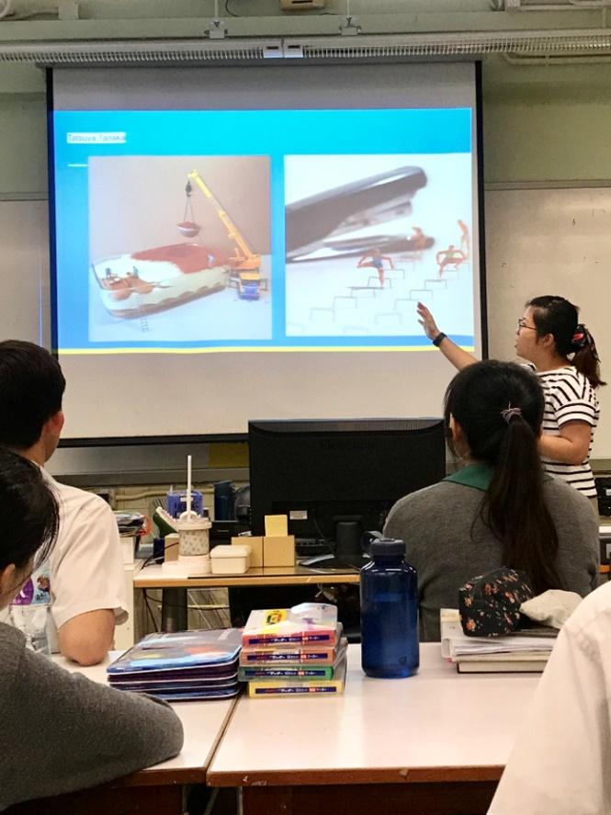  Pic 1. Introducing use of association in art creation
Quick Review(5 mins) | Briefly show students’ drafts with their creative briefs.
Gather ideas(30 mins) | Teaching Strategy:  ECA Cards (E for elements, C for creativity,  A for association)  1. Students sit as a circle.  2. Make sure each student get the draft of another student.  3. Face down all ECA cards and mix them.  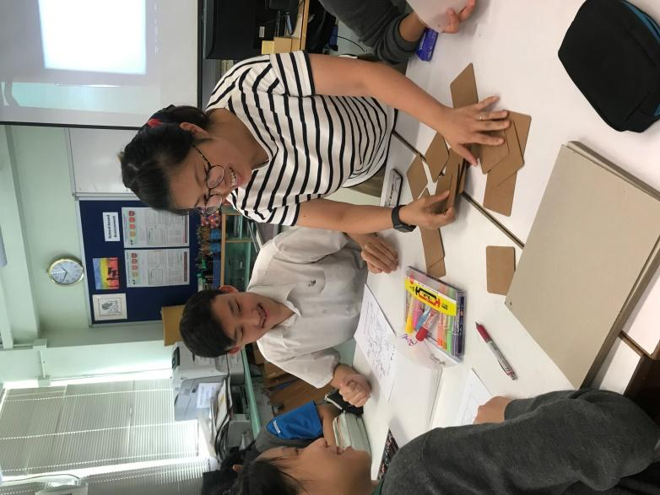  Pic 2. Demonstrating the use of ECA cards during activity  4. Each student pick one ECA card from the pile.  5. They have to follow the instruction on the ECA card, associate or modify the draft on the given paper with that ECA element.  * The association or modification should be made on a tracing paper.  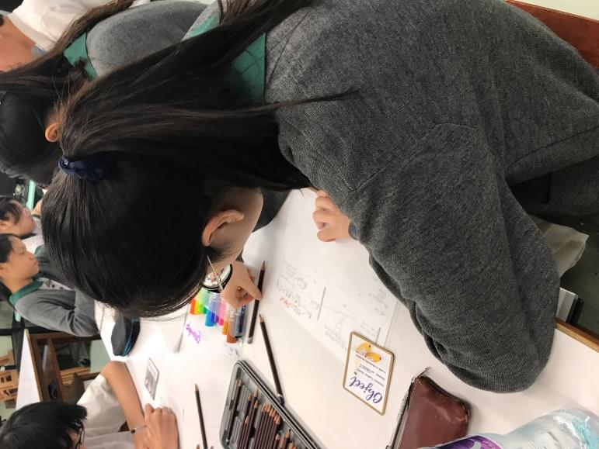  Pic 3. Modifying ideas according to the instruction of specific card  6. Duration for each round is 4-5 mins. Then the papers with be passed to another student in clockwise direction.  7. Then the cards are mixed and student have to draw a card again.
Showcase ( 10 mins ) | Students will get their draft back, together with comments and drafts of other students.  Students choose the most creative idea from other students and talk about the reason of their choices.  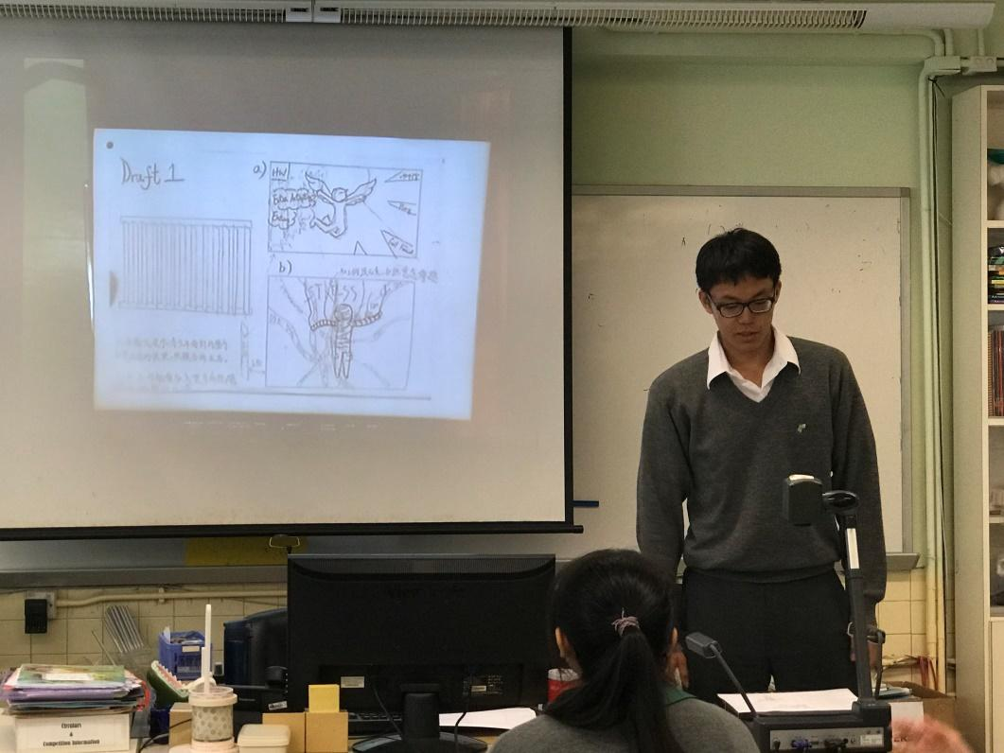  Pic 4. Student sharing session
Conclusion (5 mins) | The main purpose of the activity is to encourage feedbacks among students and develop confidence to express student’s creativity.  Assignment: Research on different comments and drafts of other students, develop a final draft for the 1st SBA works.

教學反思
在構思創意教學設計時，我一心希望令學生主動思考，勇於改善自己及他人的意念。完成試教後，我認為教學有助大部分的學生掌握創意學習的方法，在改進初步創作意念方面效果尤為顯著。不過，也許個別學生學習的意欲和對自己的期望偏低，未能掌握創意學習方法，但相信更多的嘗試和老師多加鼓勵對他們的學習能有所幫助。

